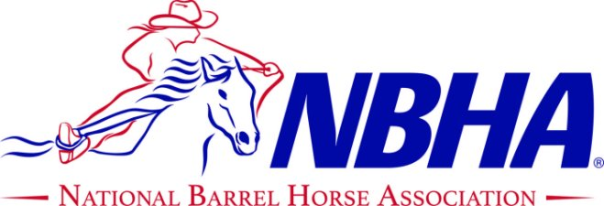

TNTN
$10,000 ADDED

2025 Tennessee STATE CHAMPIONSHIPS
@ TRI state exhibition center, McDonald, TN
Sept 26 - 28, 2025





Saturday 09/27: Office Opens at 8:30 am
Exhibitions: 9-11 am  PeeWee (CANNOT ENTER YOUTH)  4D Open 2nd Go Reverse: Noon  4D Youth 2nd Go Reverse  3D Adult 2nd Go Reverse  3D Senior 2nd Go Reverse  Exhibition Poles  Open 3D Poles  Adult and Senior Awards | $5  Free  $5  $30
Sunday 09/28
Cowboy Church: 8:30 am  4D Open Finals: 10:00 am  4D Youth Finals  Open 3D Poles  Youth and Open Awards  **11 WILDCARDS** | $30

**PRE-ENTRY DEADLINE 09/15/25**
Friday 09/26: Office Opens at 10 am
Exhibitions: Noon – 4 pm $5 each
4D Open 1st Go: 5 pm
4D Youth 1st Go
3D Adult 1st Go
3D Senior 1st Go
(Adult/Senior pay both rounds and average, average determines state champion)
Open Entry Fee $115
Youth Entry Fee $75
Adult Entry Fee $75
Senior Entry Fee $75
$25 Processing Fee
$20 Late Fee
Stalls: $80 for Fri-Sun (includes 2 bags of shavings)
RV: $80 Fri-Sun
RV/Sewer: $90 Fri-Sun

$7,000
OPEN

$1,000
Youth

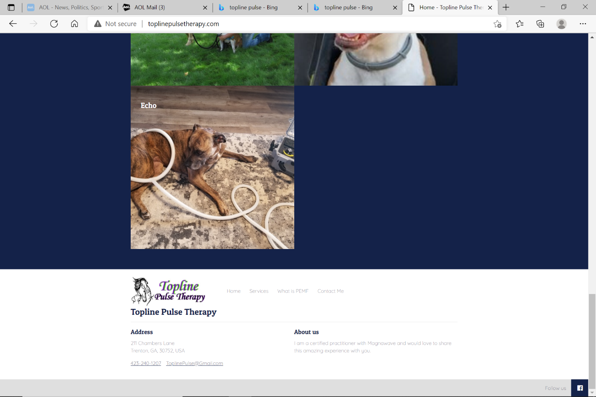







$1,000
Senior
POLES

RHONDA LEACH PHOTOGRAPHY
$1,000
ADULT
$25 Processing Fee
$20 Late Fee
Stalls: $65 for Fri-Sun (includes 2 bags of shavings)
RV: $60 Fri-Sun

